Steps to install Hadoop:
- Make sure java is installed.
Java -version

If java is not installed, then type in the following commands:
sudo apt-get install update
sudo apt-get update
sudo apt-get install default-jdk
Make sure now java is installed.
java -version

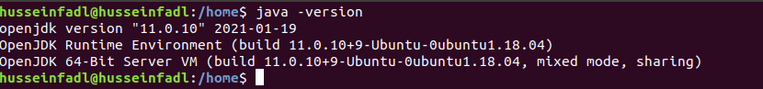

- Install ssh server
sudo apt-get install ssh-server
Generate public/private RSA key pair.
ssh-keygen -t rsa -P “”
When prompted for the file name to save the key, press Enter (leave it blank).
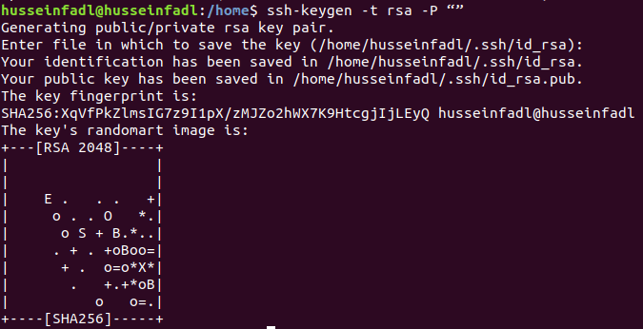
Type the following commands:
cat $HOME/.ssh/id_rsa.pub >> $HOME/.ssh/authorized_keys
ssh localhost
exit
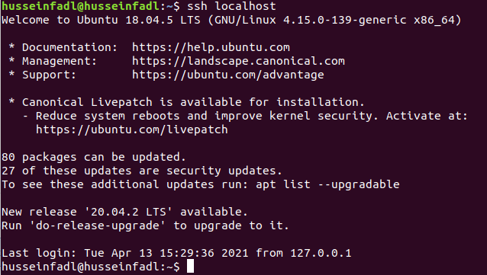
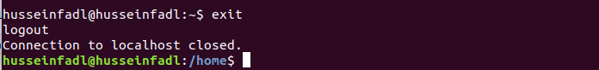
- Install Hadoop by navigating to the following link and downloading the tar.gz file for Hadoop version 3.3.0 (or a later version if you wish). (478 MB)
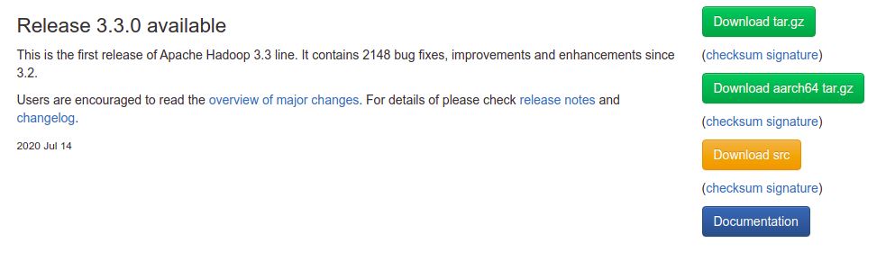
https://hadoop.apache.org/release/3.3.0.html
- Once downloaded, open the terminal and cd to the directory where it is downloaded (assume the desktop for example) and extract it as follows:
cd Desktop
sudo tar -xvzf hadoop-3.3.0.tar.gz
You can now check that there is an extracted file named hadoop-3.3.0 by typing the command “ls” or by visually inspecting the files.
- Now, we move the extracted file to the location /usr/local/hadoop
sudo mv hadoop-3.3.0 /usr/local/hadoop
- Let’s configure the hadoop system.
Type the following command:
sudo gedit ~/.bashrc
At the end of the file, add the following lines: (Note: Replace the java version with the version number you already have. You can navigate to the directory /usr/lib/jvm and check the file name java-xx-openjdk-amd64)
export JAVA_HOME=/usr/lib/jvm/java-11-openjdk-amd64
export HADOOP_HOME=/usr/local/hadoop
export PATH=$PATH:$HADOOP_HOME/bin
export PATH=$PATH:$HADOOP_HOME/sbin
export HADOOP_MAPRED_HOME=$HADOOP_HOME
export HADOOP_COMMON_HOME=$HADOOP_HOME
export HADOOP_HDFS_HOME=$HADOOP_HOME
export YARN_HOME=$HADOOP_HOME
export HADOOP_COMMON_LIB_NATIVE_DIR=$HADOOP_HOME/native
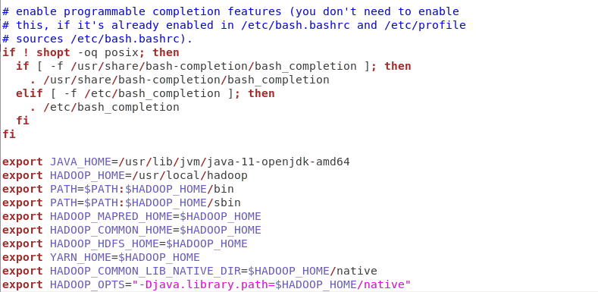
export HADOOP_OPTS="-Djava.library.path=$HADOOP_HOME/native"

- Save the file and close it.
- Now from the terminal, type the following command:
source ~/.bashrc
- We start configuring Hadoop by opening hadoop-env.sh as follows:
sudo gedit /usr/local/hadoop/etc/hadoop/hadoop-env.sh
Search for the line starting with export JAVA_HOME= and replace it with the following line.
export JAVA_HOME=/usr/lib/jvm/java-11-openjdk-amd64
Save the file by clicking on “Save” or (Ctrl+S)
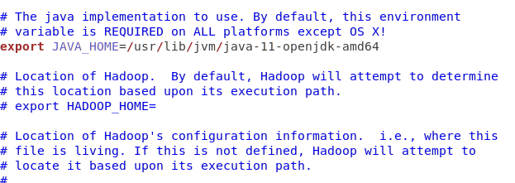

- Open core-site.xml as follows:
sudo gedit /usr/local/hadoop/etc/hadoop/core-site.xml
Add the following lines between the tags <configuration> and </configuration> and save it (Ctrl+S).
<property>
<name>fs.default.name</name>
<value>hdfs://localhost:9000</value>
</property>
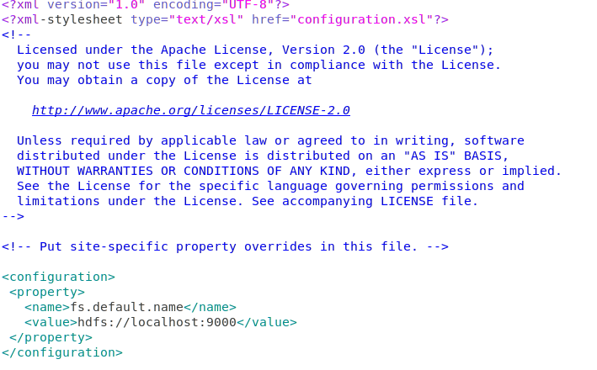

- Open hdfs-site.xml as follows:
sudo gedit /usr/local/hadoop/etc/hadoop/hdfs-site.xml
Add the following lines between the tags <configuration> and </configuration> and save it (Ctrl+S).
<property>
<name>dfs.replication</name>
<value>1</value>
</property>
<property>
<name>dfs.namenode.name.dir</name>
<value>file:/usr/local/hadoop_space/hdfs/namenode</value>
</property>
<property>
<name>dfs.datanode.data.dir</name>
<value>file:/usr/local/hadoop_space/hdfs/datanode</value>
</property>
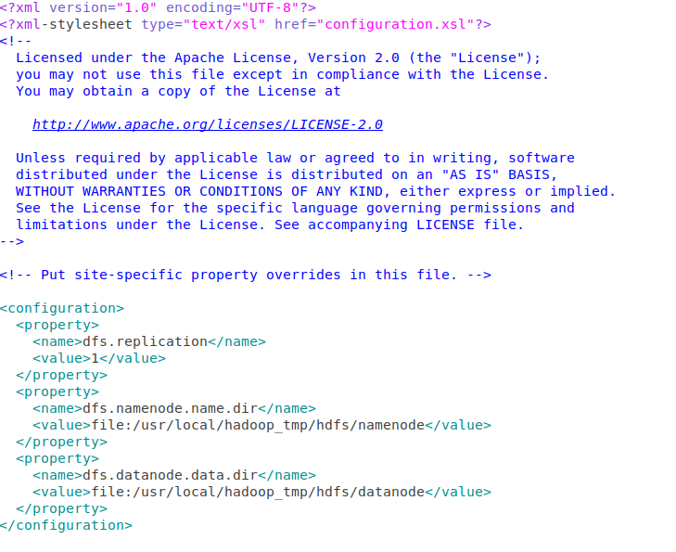

- Open yarn-site.xml as follows:
sudo gedit /usr/local/hadoop/etc/hadoop/yarn-site.xml
Add the following lines between the tags <configuration> and </configuration> and save it (Ctrl+S)
<property>
<name>yarn.nodemanager.aux-services</name>
<value>mapreduce_shuffle</value>
</property>
<property>
<name>yarn.nodemanager.aux-services.mapreduce.shuffle.class</name>
<value>org.apache.hadoop.mapred.ShuffleHandler</value>
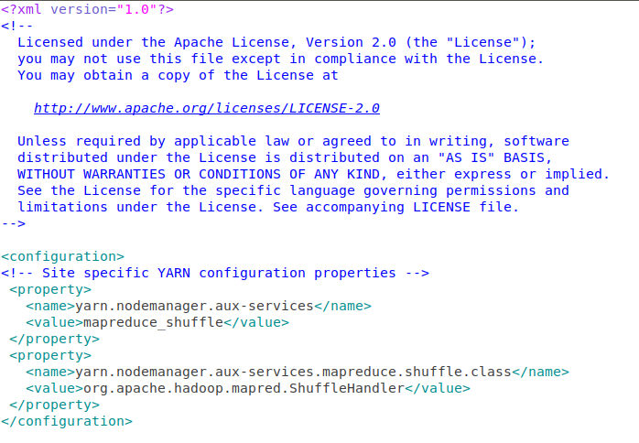
</property>

- Open mapred-site.xml as follows:
sudo gedit /usr/local/hadoop/etc/hadoop/mapred-site.xml
Add the following lines between the tags <configuration> and </configuration> and save it (Ctrl+S)
<property>
<name>mapreduce.framework.name</name>
<value>yarn</value>
</property>
<property>
<name>yarn.app.mapreduce.am.env</name>
<value>HADOOP_MAPRED_HOME=${HADOOP_HOME}</value>
</property>
<property>
<name>mapreduce.map.env</name>
<value>HADOOP_MAPRED_HOME=${HADOOP_HOME}</value>
</property>
<property>
<name>mapreduce.reduce.env</name>
<value>HADOOP_MAPRED_HOME=${HADOOP_HOME}</value>
</property>
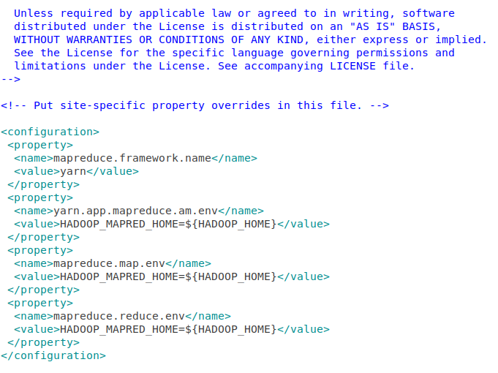

- Now, run the following commands on the terminal to create a directory for hadoop space, name node and data node.

- sudo mkdir -p /usr/local/hadoop_space
- sudo mkdir -p /usr/local/hadoop_space/hdfs/namenode
- sudo mkdir -p /usr/local/hadoop_space/hdfs/datanode
Now we have successfully installed Hadoop.
- Format the namenode as follows:
hdfs namenode -format
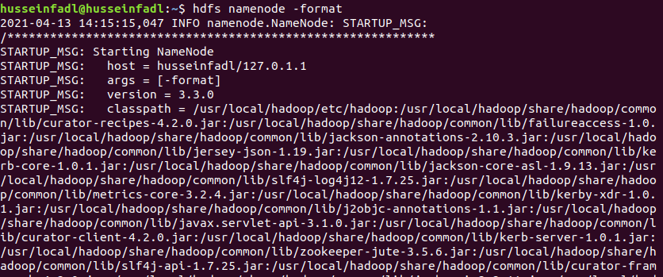
This step should end by shutting down the namenode as follows:
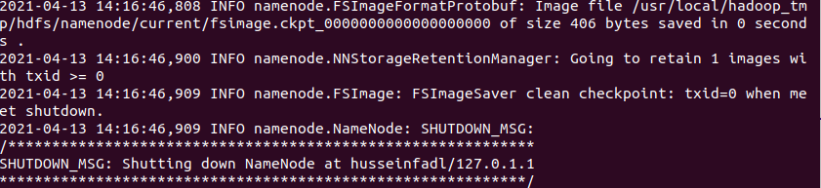

- Before starting the Hadoop Distributed File System (hdfs), we need to make sure that the rcmd type is “ssh” not “rsh” when we type the following command
- pdsh -q -w localhost
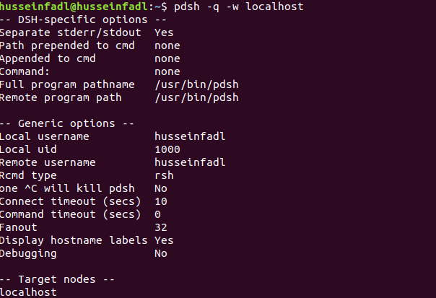
- If the rcmd type is “rsh” as in the above figure, type the following commands:
export PDSH_RCMD_TYPE=ssh
cat $HOME/.ssh/id_rsa.pub >> $HOME/.ssh/authorized_keys
chmod 0600 ~/.ssh/authorized_keys
Run Step 16 again to check that the rcmd type is now ssh.
If not, skip that step.

- Start the HDFS System using the command.
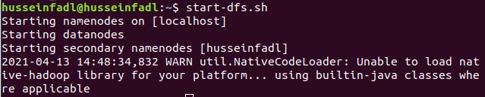
start-dfs.sh
- Start the YARN using the command
start-yarn.sh
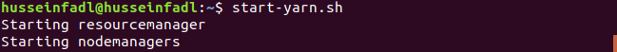
- Type the following command. You should see an output similar to the one in the following figure.
jps
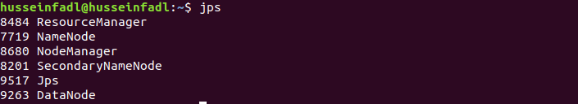

Make sure these nodes are listed: (ResourceManager, NameNode, NodeManager, SecondaryNameNode, Jps and DataNode).

- Go to localhost:9870 from the browser. You should expect the following
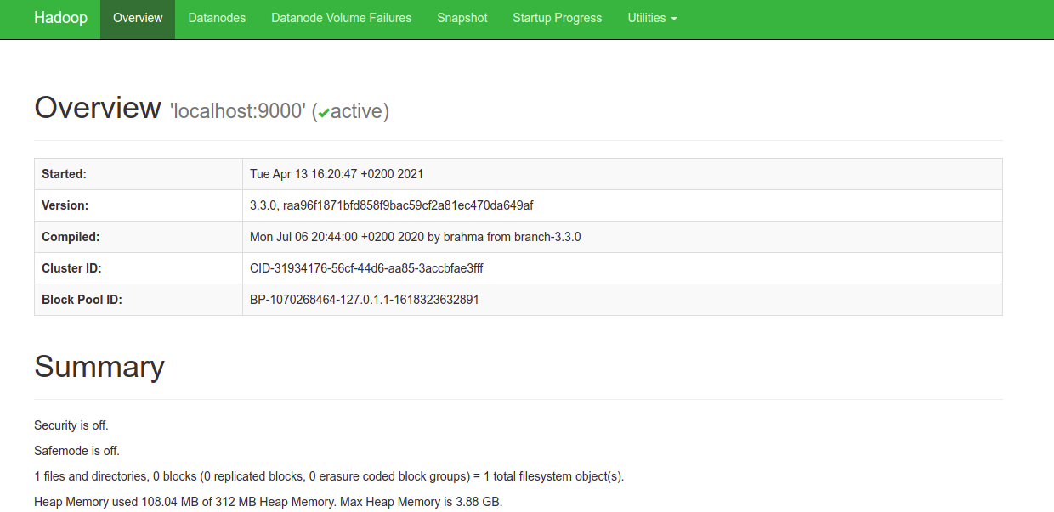

Steps to run WordCount Program on Hadoop:
- Make sure Hadoop and Java are installed properly
hadoop version
javac -version

- Create a directory on the Desktop named Lab and inside it create two folders; one called “Input” and the other called “tutorial_classes”.
[You can do this step using GUI normally or through terminal commands]
cd Desktop
mkdir Lab
mkdir Lab/Input
mkdir Lab/tutorial_classes

- Add the file attached with this document “WordCount.java” in the directory Lab

- Add the file attached with this document “input.txt” in the directory Lab/Input.

- Type the following command to export the hadoop classpath into bash.
export HADOOP_CLASSPATH=$(hadoop classpath)
Make sure it is now exported.
echo $HADOOP_CLASSPATH
- It is time to create these directories on HDFS rather than locally. Type the following commands.
hadoop fs -mkdir /WordCountTutorial
hadoop fs -mkdir /WordCountTutorial/Input
hadoop fs -put Lab/Input/input.txt /WordCountTutorial/Input
- Go to localhost:9870 from the browser, Open “Utilities → Browse File System” and you should see the directories and files we placed in the file system.
- Then, back to local machine where we will compile the WordCount.java file. Assuming we are currently in the Desktop directory.
cd Lab
javac -classpath $HADOOP_CLASSPATH -d tutorial_classes WordCount.javaPut the output files in one jar file (There is a dot at the end)
jar -cvf WordCount.jar -C tutorial_classes .

- Now, we run the jar file on Hadoop.
hadoop jar WordCount.jar WordCount /WordCountTutorial/Input /WordCountTutorial/Output

- Output the result:
hadoop dfs -cat /WordCountTutorial/Output/*

